**Printing a PDF with Foxit PDF Reader**

To print a PDF file from Foxit PDF Reader, first save your original file in an easy to find spot, such as the desktop. To do this in Acrobat Reader, select the **Menu** option in the upper left, then **Save As:**

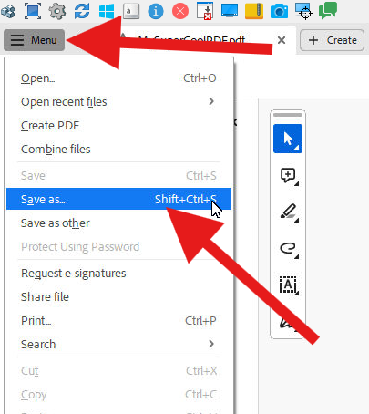  
When prompted, select **Choose a different folder:**

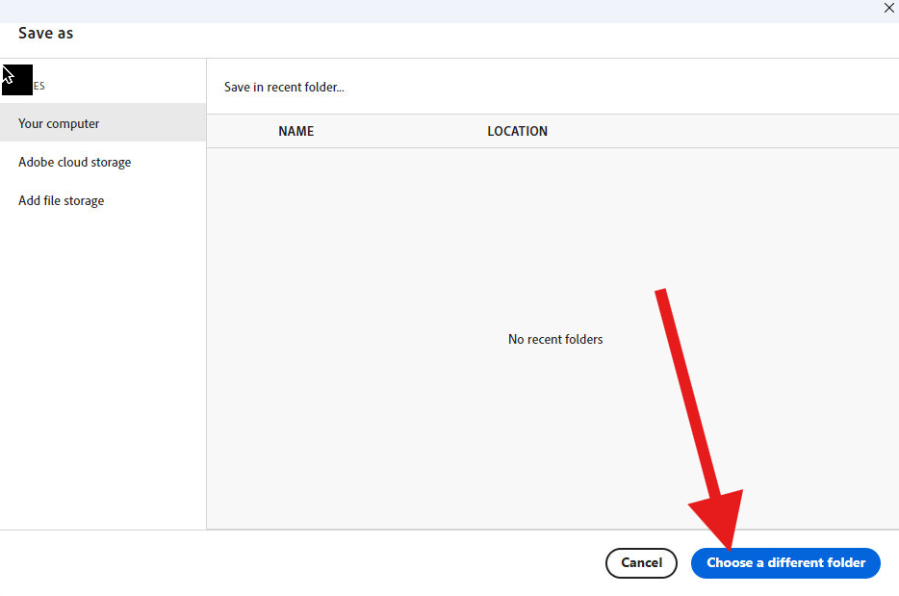  
In the next menu, select **Desktop** in the left pane, enter a name for your file in **File Name:** field, then select **Save.**

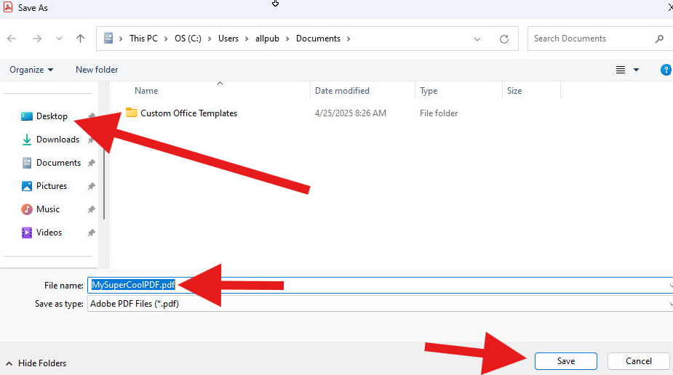

Next, locate your file on the desktop, or in the location to which it was saved in the previous step:

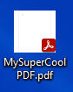

Right-click the file with the mouse, and select **Open With -> Foxit PDF Reader** from the menu:

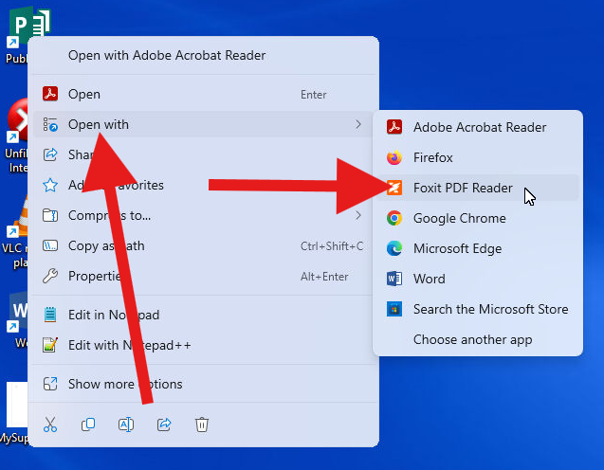

When the file loads, select the **File** menu in Foxit PDF Reader, and then **Print:**

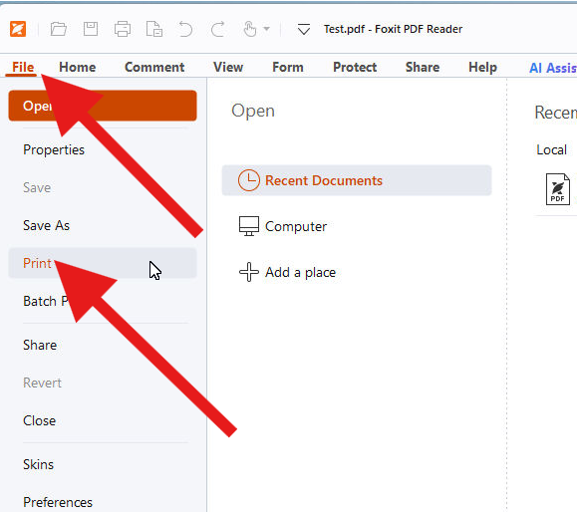  
  
Choose your desired print options and print the file. It will be available to print at the print release station as usual.